PRACTICE EXAM QUESTIONS (II)
[6, 5, 12 = 23 marks]
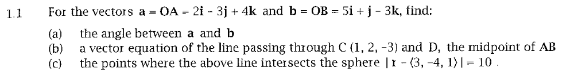

PRACTICE EXAM QUESTIONS (II) – SOLUTIONS


























